POLICY NUMBER: ED 71

SUSTAINABILITY FOOD POLICY STATEMENT
Student and Campus Life Directorate

Policy Number | ED 71
Version Number | 2
Approval Date | June 2020
Approved By | Brian Horgan, Head of Campus Food and Drink
Review Date | Jan 2025 (last reviewed 2024)
Lead Responsibility | Brian Horgan, Head of Campus Food and Drink
Lead Author | Brian Horgan, Head of Campus Food and Drink

.

Developed by Campus Food and Drink

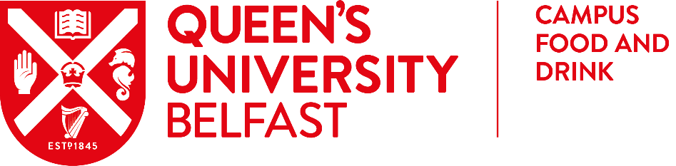

Queen’s University Sustainable Food Policy

Purpose

Our University Strategy 2030 commits us to drive social change, embrace the sustainable development goals and transition to a carbon neutral society.
This sustainable food policy outlines our commitment to ensure that food and drink is produced, sourced, consumed and disposed of in a way which takes account of our environmental impact, has a positive benefit on our society and raises animal welfare standards.

As part of our commitment, we recognise our responsibility to provide healthy, seasonal, local and responsibly sourced food to our staff, students, and visitors which will reduce our social and environment impact and promote positive experiences for those learning, working and visiting the University.

The Sustainable Food Policy provides a framework for our commitments to ensure that food and drink is produced, sourced, consumed and disposed of in such a way that considers the protection of the environment, provides benefit for society and that sets high standards for animal welfare.

We will commit to embedding sustainability in the following areas;

Sourcing

- Support a vibrant local economy in Northern Ireland, strengthening community links and reducing food miles by using local, seasonal products and suppliers.
- Work with colleagues in Procurement to ensure sustainability is embedded in every procurement project we undertake.
- Support the Northern Ireland agricultural industry by as much as possible only purchasing poultry, lamb, pork and beef that has been reared in Northern Ireland.
- Ensuring that all catering on campus meets current best practice benchmarks and standards.
- Exclude fish species identified as most at risk by the Marine Conservation Society, and only choose fish from sustainable sources, such as those accredited by the Marine Stewardship Council.
- Ensure Campus Food and Drink continue to comply with The University Caterers organisation’s (TUCO) Frameworks and support Fairtrade and ethical trade via there supply chain. Continual review into potential participation of further relevant benchmarks and standards will take place annually (E.g. Food for Life Served Here Award, Food Made Good Rating).

Environment

- Manage our waste effectively so we can reduce, re-use and recycle where possible.
- Ensure that we promote plant-based menus and actively encourage healthy, sustainable options.
- Enhance animal welfare and a sustainable agricultural environment through the use of free range and organic products.
- Minimise environmental impact and resource use by reducing waste and rationalising transport, as well as reducing consumption of gas, energy and water.

Society

- Ensure that links between sustainability and wellbeing are made clear in the context of the catering provision via social media, roundup and our website.
- Contribute to social justice and equity through use and promotion of Fairtrade and other ethically produced products.
- Continue to work with students and staff on relevant sustainable food projects, including Living Lab and Fairtrade Projects.
- Promote equality and diversity by expanding the range and cultural variety of all menus.
- Embrace the ethos of healthy eating by promoting healthy foods and avoiding the promotion of unhealthy options.
- Enable positive dietary changes by reducing foods high in saturated fat, salt and free sugars and increasing the provision of higher fibre foods, fruit, vegetables and oily fish.
- Treat our employees fairly, pay our suppliers on time and make sure our customers experience the highest levels of service.
- Adopt a marketing and communications strategy to actively promote our sustainable and environmental activities.

Responsibility and Scope:

This Sustainable Food Policy covers all food outlets and hospitality food and drink served by Queen’s University Belfast.

Implementation and Review:

This policy will be available to staff, students and visitors via our website. Campus Food and Drink will review the policy every 3 years to respond to new developments and meet evolving best practice in the sector.

An action plan will be produced and updated annually. Progress against this action plan by Campus Food and Drink and the Procurement Office will be reported to the University Sustainability Board at least annually and all other relevant groups. Highlights will be reported in the Annual Sustainability Report.
Signature Date 12 Jan 2024 Date for review: 1 Jan 2025

